**ADVANCE EXCEL ASSIGNMENT - 14**

**Dataset:**

**https://docs.google.com/spr eadsheets/d/1-ZoA4gnlLOQxpU8qgpkTJPJCS8cQBmNzKVirJ_Ow0w/edit?usp=sharing**

**Use the above dataset and answer the following questions. Assume that a gang is trying to loot Diamonds and Soft drinks being exported from India**

**1. How much Diamonds were looted from Chennai Port Trust?**

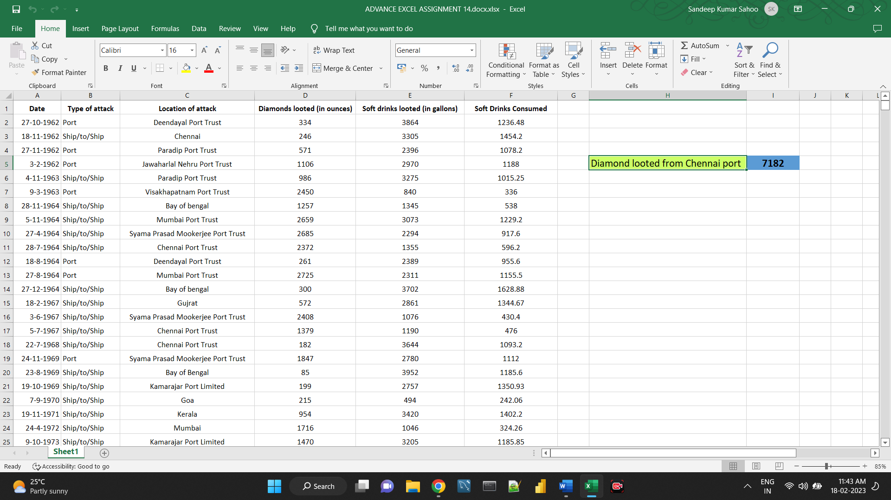

**2. How many Ships were looted near Paradip Port Trust and Chennai Port Trust?**

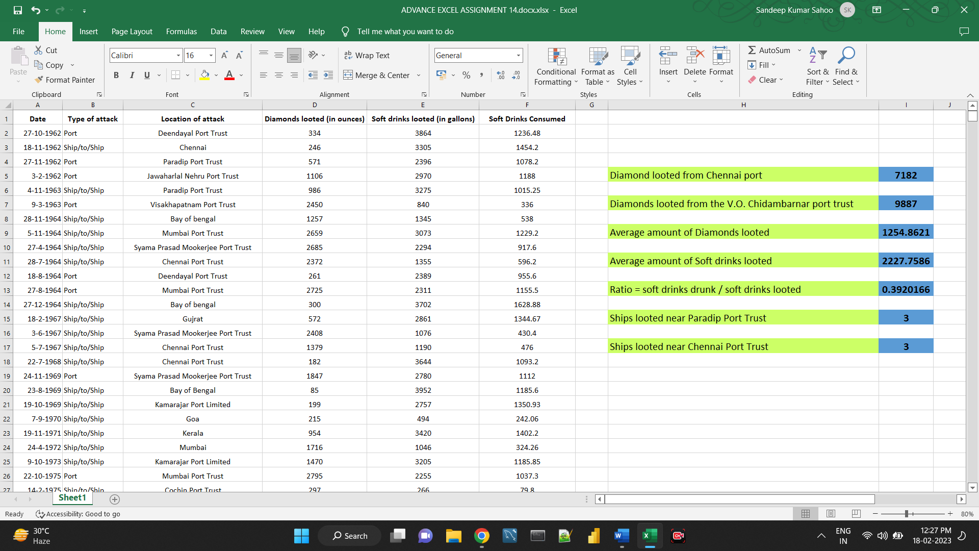

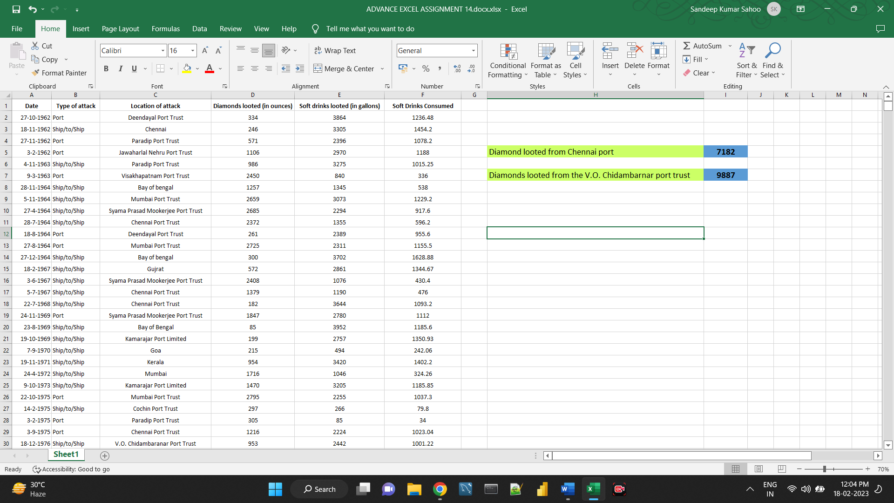**3. What is the sum total of Diamonds looted from the V.O. Chidambarnar port trust?**

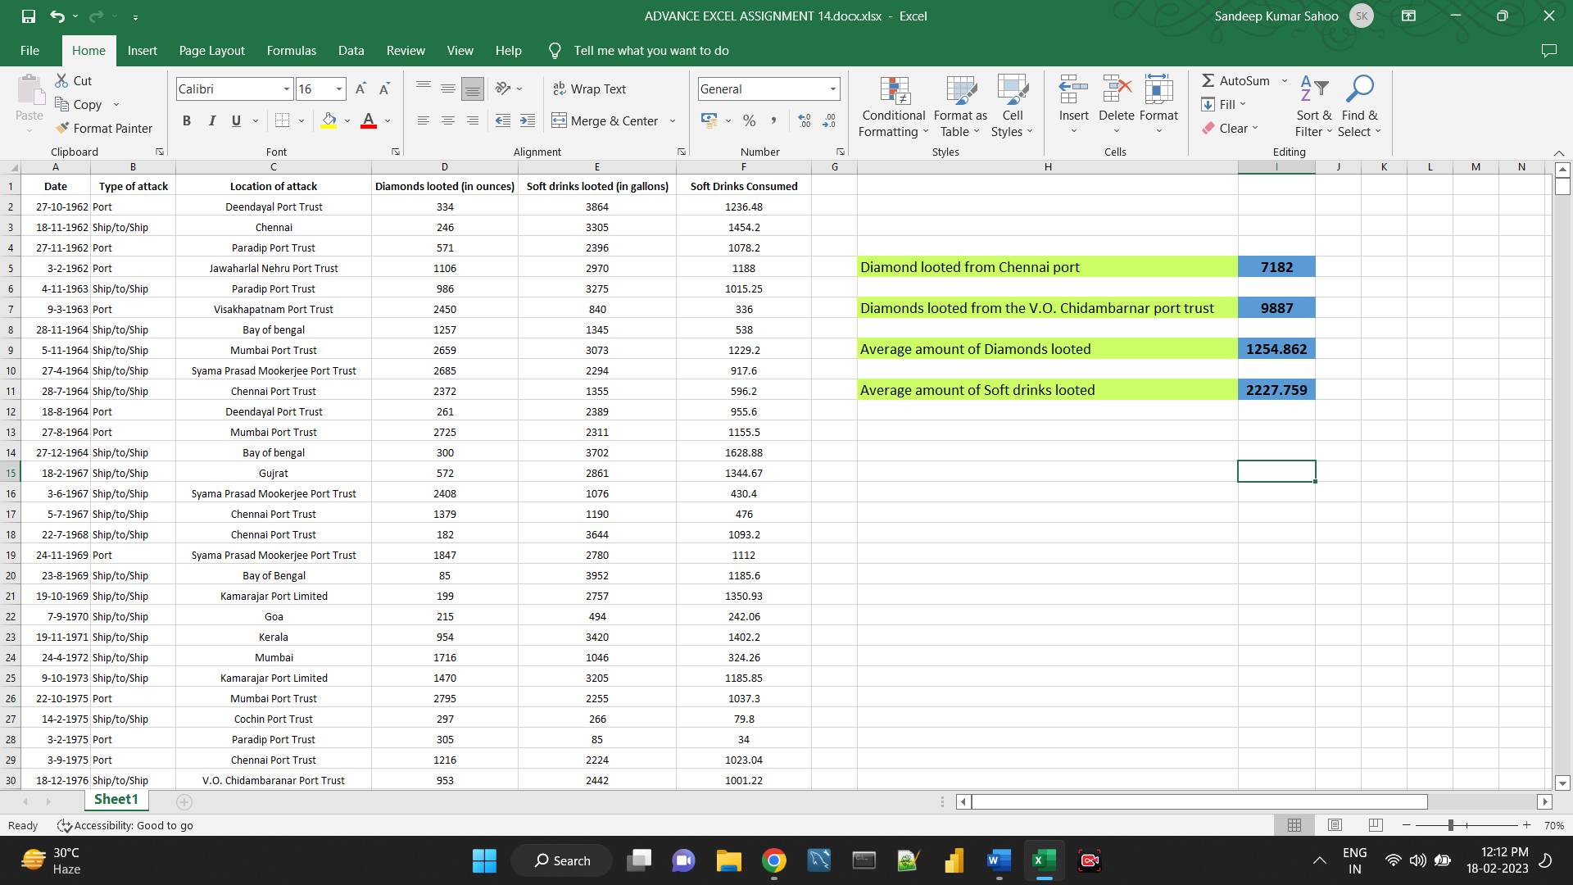**4. What is the average amount of Diamonds and Soft drinks looted?**

**5. What is the ratio of soft drinks drunk to soft drinks looted?**

